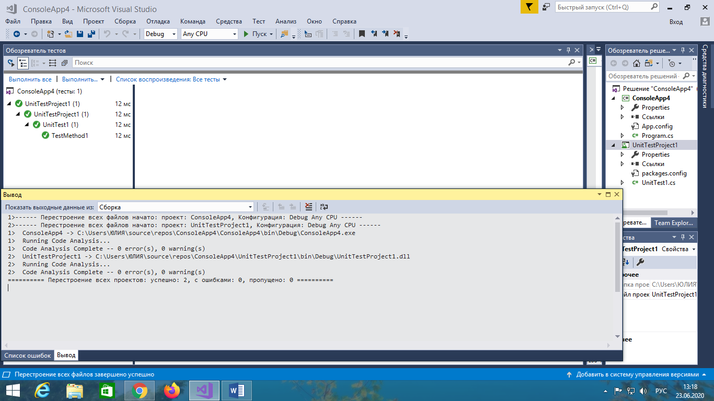

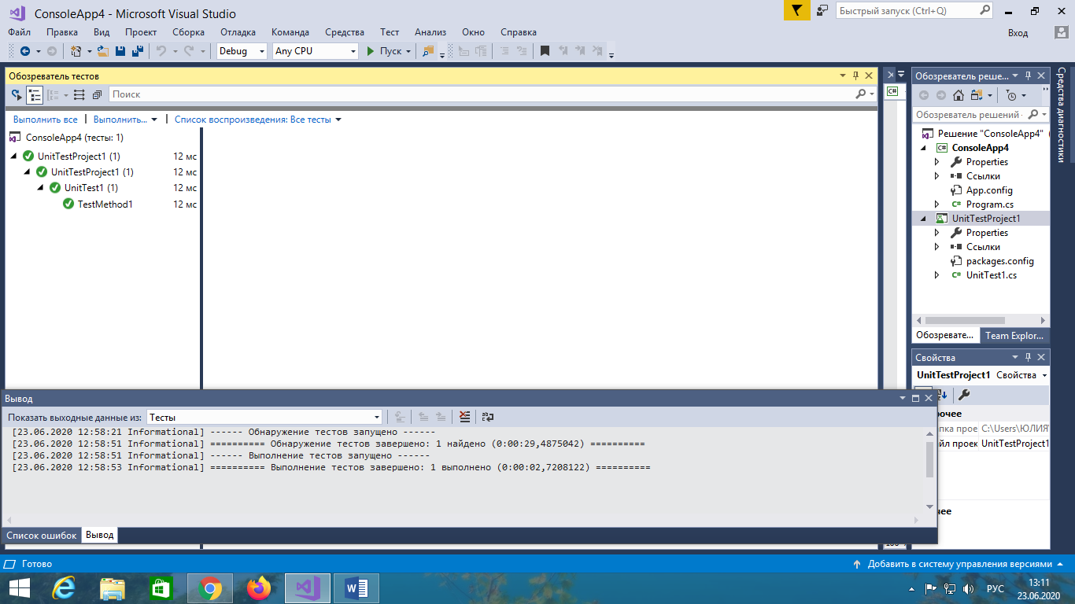

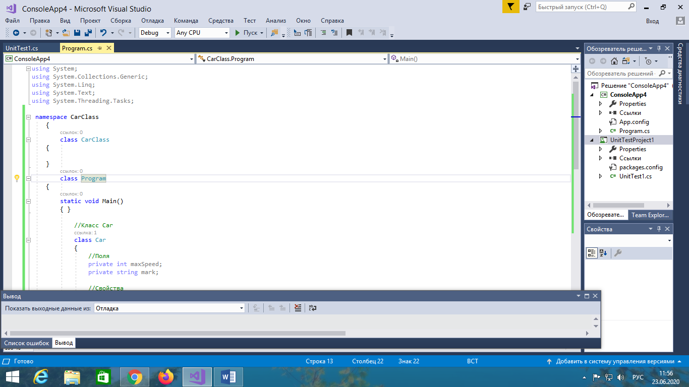

namespace CarClass

{

class CarClass

{

}

class Program

{

static void Main()

{ }

//Класс Car

class Car

{

//Поля

private int maxSpeed;

private string mark;

//Свойства

public int MaxSpeed

{

get

{ return maxSpeed; }

set

{ maxSpeed = value; }

}

public string Mark

{

get

{ return mark; }

set

{ mark = value; }

}

//Конструктор класса Car

public Car(int maxSpeed, string mark)

{

this.maxSpeed = maxSpeed;

this.mark = mark;

}

}

}

}